BST AVL Tree

**Summary:**

This program implements the **Self-Balanced Binary Search** **Tree**, with the Insert, Delete Functions. You can display Balanced AVL Tree with (InOrder traversal, PreOrder traversal, PostOrder traversal)

The project is built using **C++, Visual Studio**.

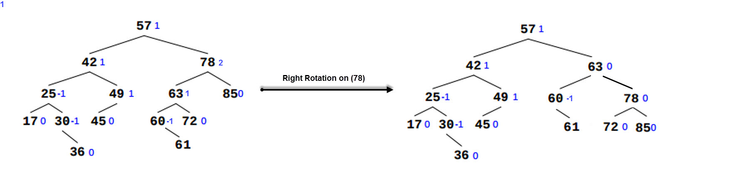**Example1:   
Add** the element with value 61. This happens in two steps: Step1: just add the node to the tree.  
Step2: make the tree balance.

**Example2:**1) **Delete** the node with value 60   
2) **Delete** the node with value 78  
3) **Delete** the node with value 42

